Missionaries and Cannibals

Aim

To solve the Missionaries and Cannibals problem using Artificial Intelligence search techniques.

Objectives

Represent the problem as a state-space search.

Find a safe sequence of moves.

Ensure missionaries are never outnumbered by cannibals on either river bank.

Algorithm

1. Start with 3 missionaries and 3 cannibals on the left bank.

2. Move one or two people across the river by boat.

3. After each move, check that missionaries are not outnumbered by cannibals on either bank (unless there are no missionaries on that bank).

4. Continue generating valid moves.

5. Stop when all missionaries and cannibals reach the right bank safely.

Pseudocode

START
Initialize initial state (3M,3C,Left)
Initialize goal state (0M,0C,Right)
Generate valid moves
Check safety of each state
Repeat until goal is reached
Display solution path
STOP

Python Code

from collections import deque

start = (3, 3, 1)
goal = (0, 0, 0)

moves = [(1,0),(2,0),(0,1),(0,2),(1,1)]

def safe(m, c):
return (m == 0 or m >= c) and ((3-m) == 0 or (3-m) >= (3-c))

queue = deque([(start, [])])
visited = set()

while queue:
state, path = queue.popleft()
if state == goal:
print(path + [state])
break

if state in visited:
continue
visited.add(state)

m, c, boat = state
for dm, dc in moves:
if boat:
nm, nc, nb = m-dm, c-dc, 0
else:
nm, nc, nb = m+dm, c+dc, 1

if 0 <= nm <= 3 and 0 <= nc <= 3 and safe(nm, nc):
queue.append(((nm, nc, nb), path + [state]))

Result

The Missionaries and Cannibals problem was solved successfully, finding a safe sequence of crossings from the left bank to the right bank.

Sample Output

Solution path found successfully.
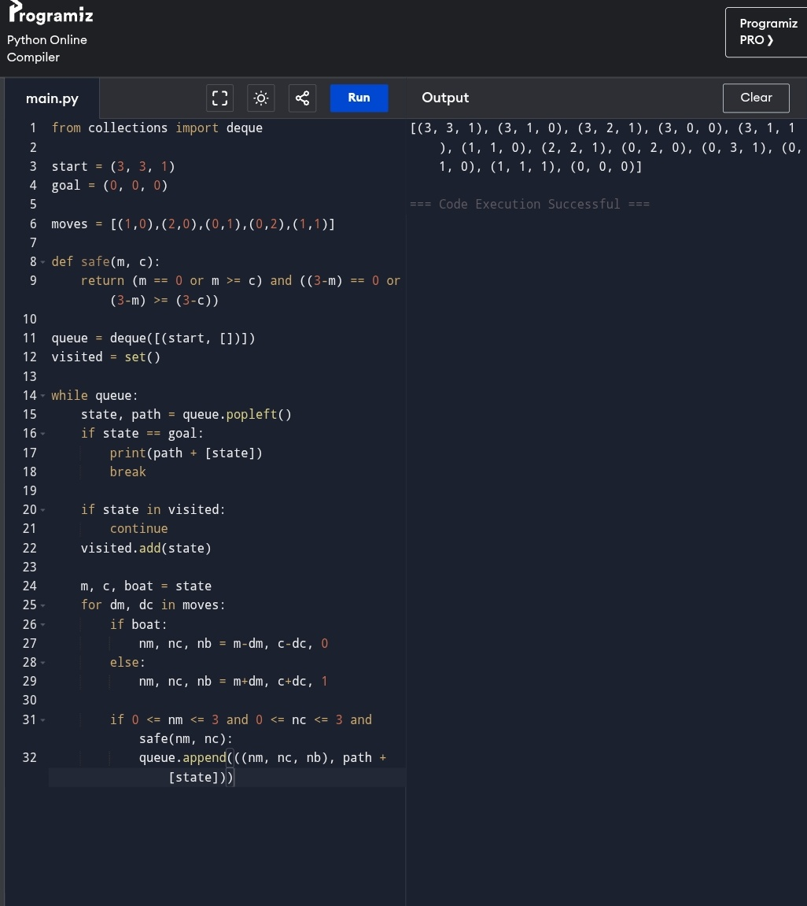

Flowchart

START
│
▼
Initialize Start State
│
▼
Generate Valid Moves
│
▼
Check Safety
│
┌─┴─────────┐
│ Safe? │
└─┬──────┬──┘
│Yes │No
▼ ▼
Next State Ignore
│
▼
Goal Reached?
│
┌─┴─────┐
│ No │
└─┬─────┘
│
▼
Repeat
│
▼
STOP

